# Task P8.1.2

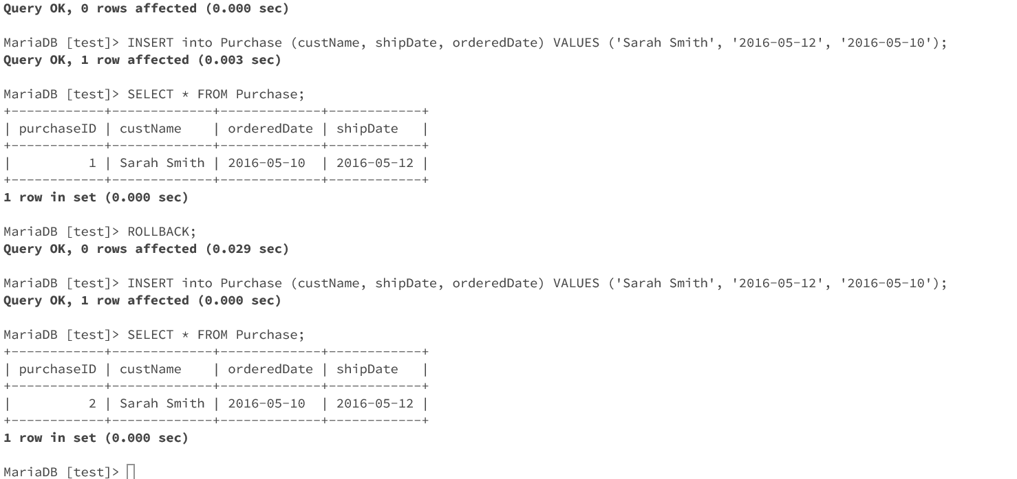

** First query inserts new row in table but it is not become permanent until we pass COMMIT command as we have AUTOCOMMIT set to false. Now ROLLBACK will delete the changes for given instance for the table. As seen, when we insert following query again it adds in table but with next value of auto increment field as database already has assigned first value to the row we deleted. This helps in keeping track of deleted data and increase data redundancy.

Insert into PurchasedItem (purchaseID, itemNo, productName, or

deredqty, quotedPrice) VALUES (**LAST_INSERT_ID()**, 1, 'Cricket bat', 2, 80.50);

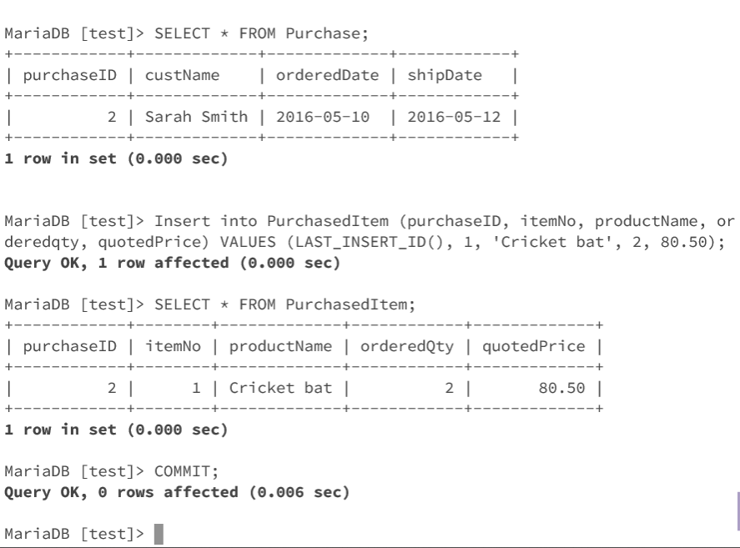

** LAST_INSERT_ID() function adds value of parent table’s autoincrement field into given query. Value is associated only with last parent statement successfully executed for given instance.